Description : This query identifies the top 10 most popular products based on the number of records or orders. It helps determine which products are most frequently purchased or promoted.

Query :

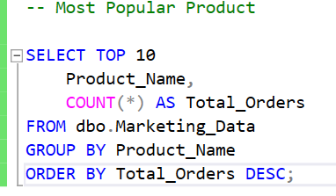

Solution :
